R. Gonzalez Management Inc. (RGM)
Student Financial Aid Services Phone No. (323) 730-8700
3560 S. La Cienega Blvd. Suite G Fax No. (323) 730-8701
Los Angeles, CA 90016-4400 Web Page http://www.rgmsms.com
RGM Memo
Date: June 3, 2016
To: Dear School Owners and Financial Aid Personnel,
RE: Reporting Results on CPS for Verification Groups V4 and V5
On November 6, 2014 an Electronic Announcement was posted reminding of the Institutional Responsibility to Report the Results of Verification Groups V4 and V5. We provide the link below to that Electronic Announcement.

Please copy and paste to your browser:

http://ifap.ed.gov/eannouncements/110614ReminderInstResponsibilityRprtRsltsVerifiV4V5.html

Below are some screenshots on the process to posting the results in CPS:
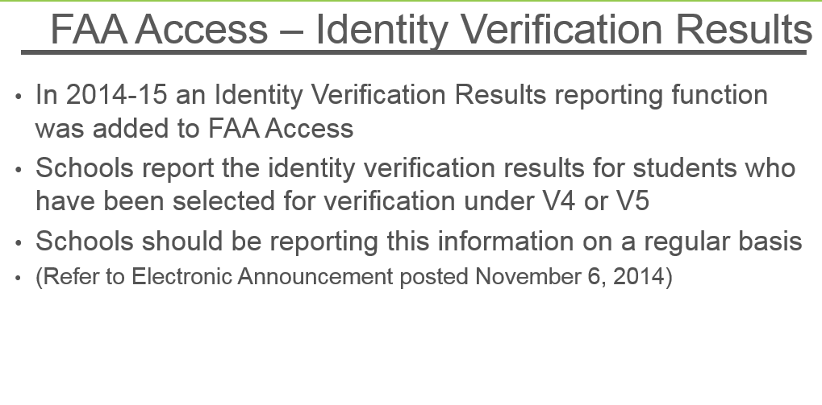

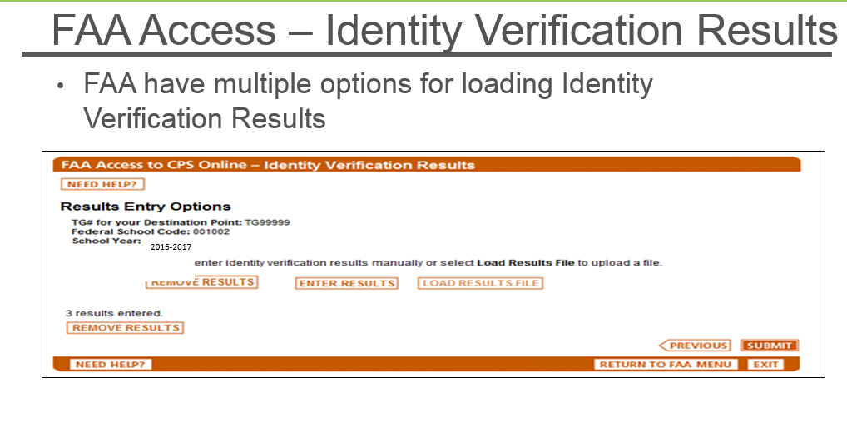

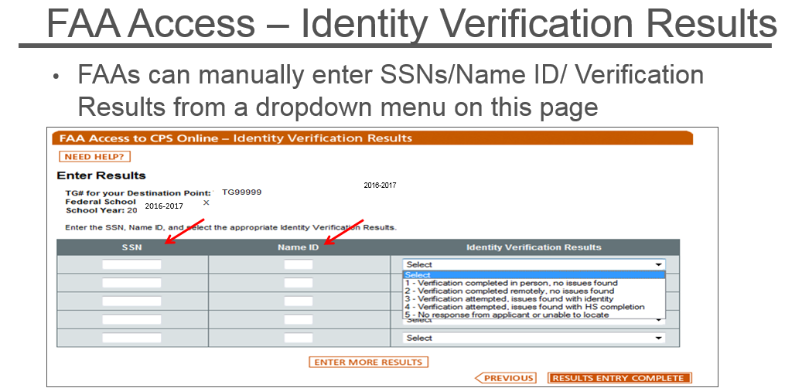

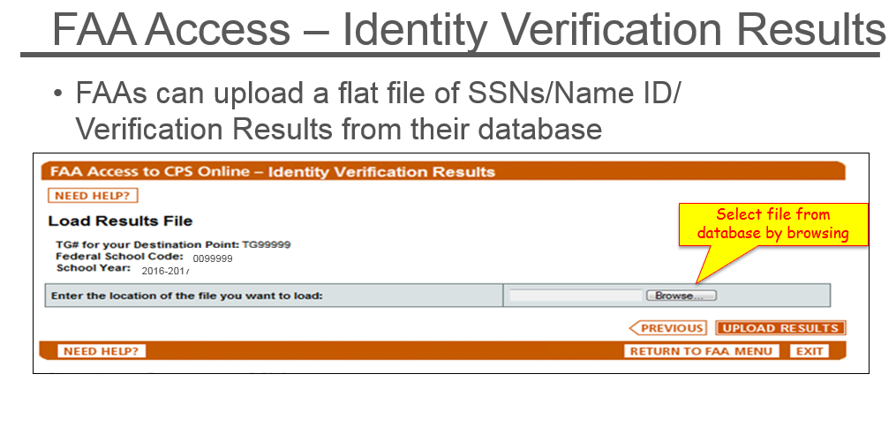
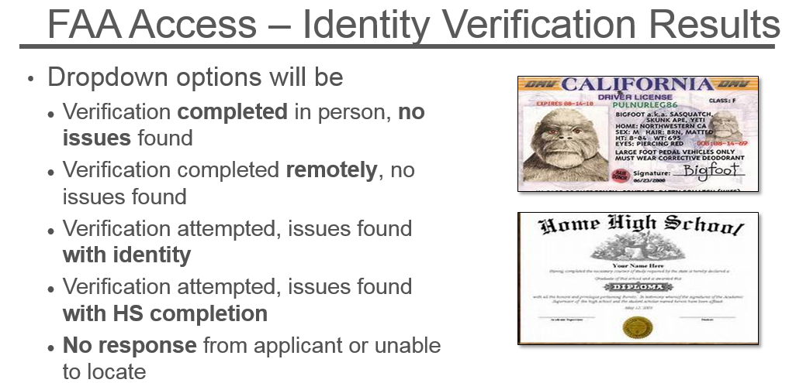

Below is the section from the Financial Aid Handbook 2015-2016:
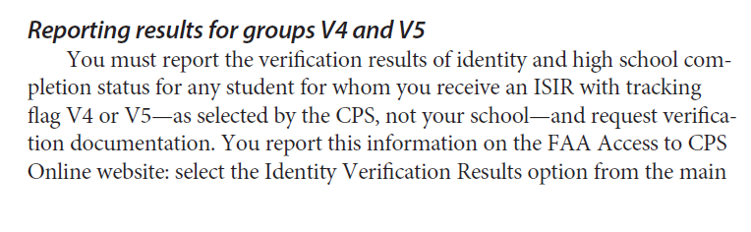
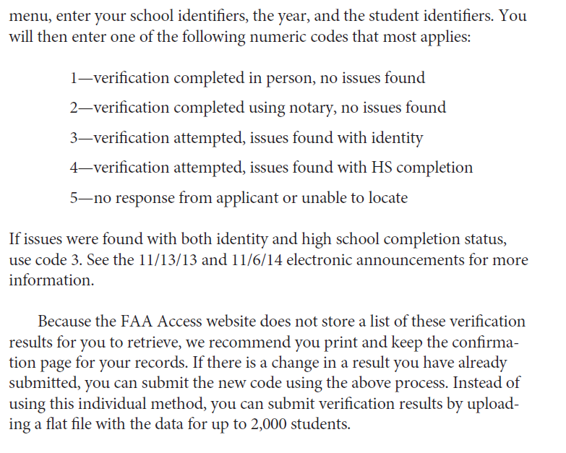

You can also download V4 and V5 results from the RGM system. Please see the steps below:

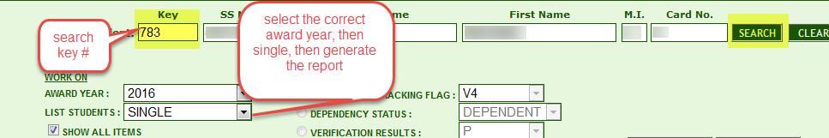

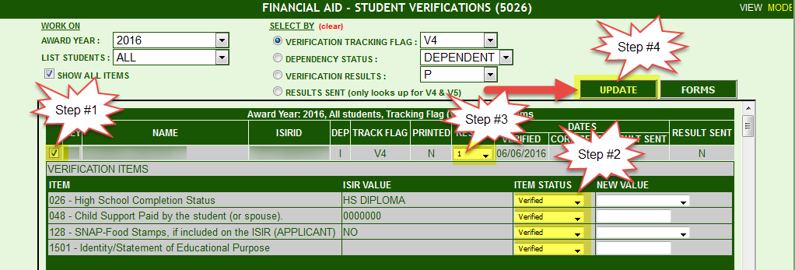

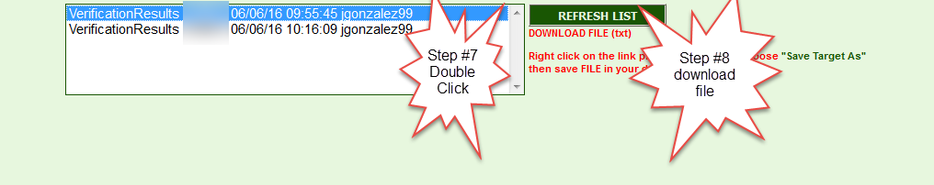

Go to FAA Access to CPS Online, https://faaaccess.ed.gov , after logging in, Click “Identity Verification Results.”

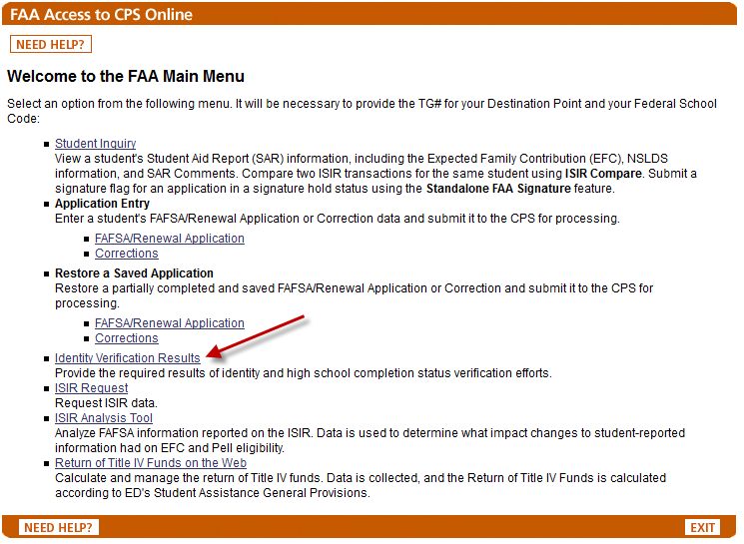

You will need enter the following information: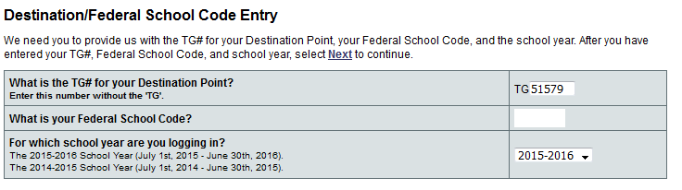

The TG # that you will use is RGM TG#51579. Your Federal School Code can be found in the RGM system in TRX#1003, under the “Financial Aid Settings” Tab, under FPELL ID.

You have two options to upload the information:
- If you choose to enter the results, you will need to enter the SSN, Name ID (First two characters of the Last Name in the ISIR ID) and the results. After you are done, Click “Results Entry Complete.”
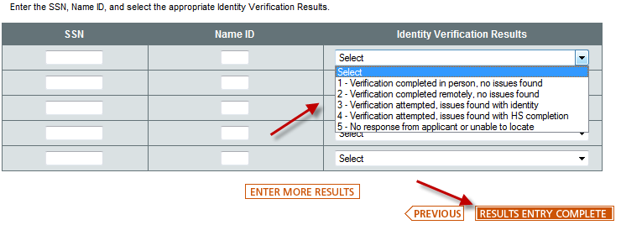
- You can upload the information using the file that was created in our system to CPS by Clicking “Load Results File.”
Browse to the file location (where you’ve downloaded the file from the RGM system) and insert the file. Once done, click “Upload Results”

The result reporting for V4 and V5 has been a requirement since the award year 2014-2015. Please remember that schools should be reporting this on a regular basis.

Thank You
Rafael

